TALLER 4 Y 5

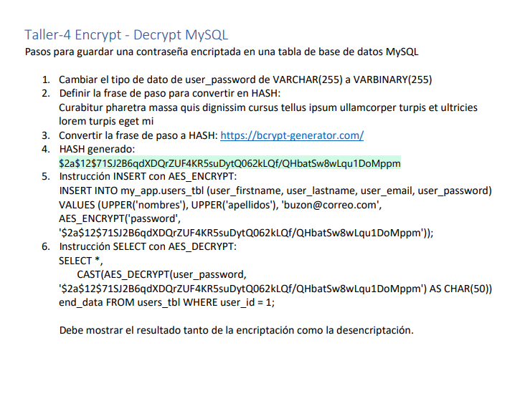

**CLASE:** **BasicConnection:**

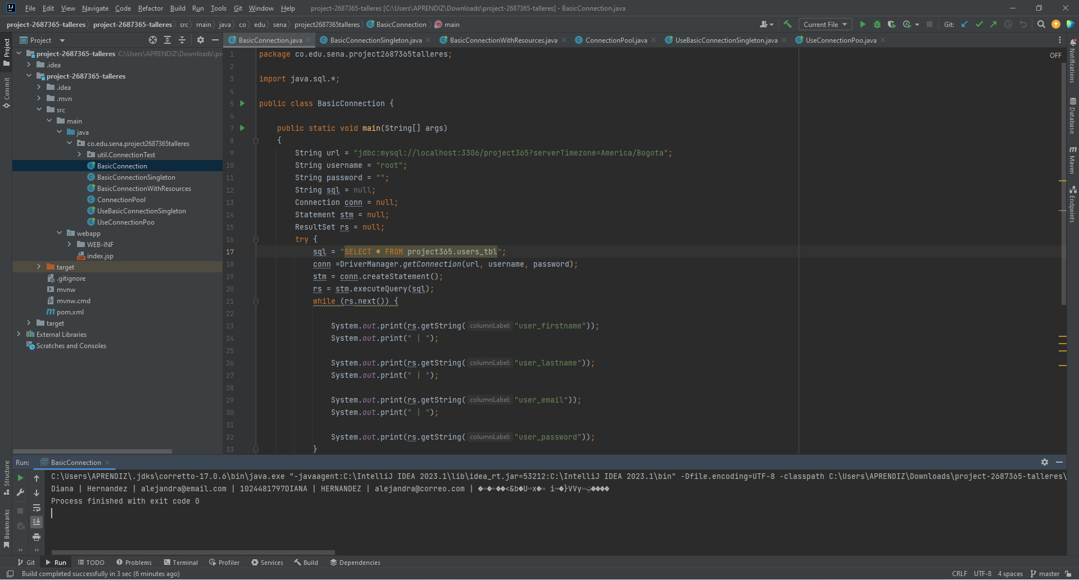

**CLASE:** **BasicConnectionSingleton:**

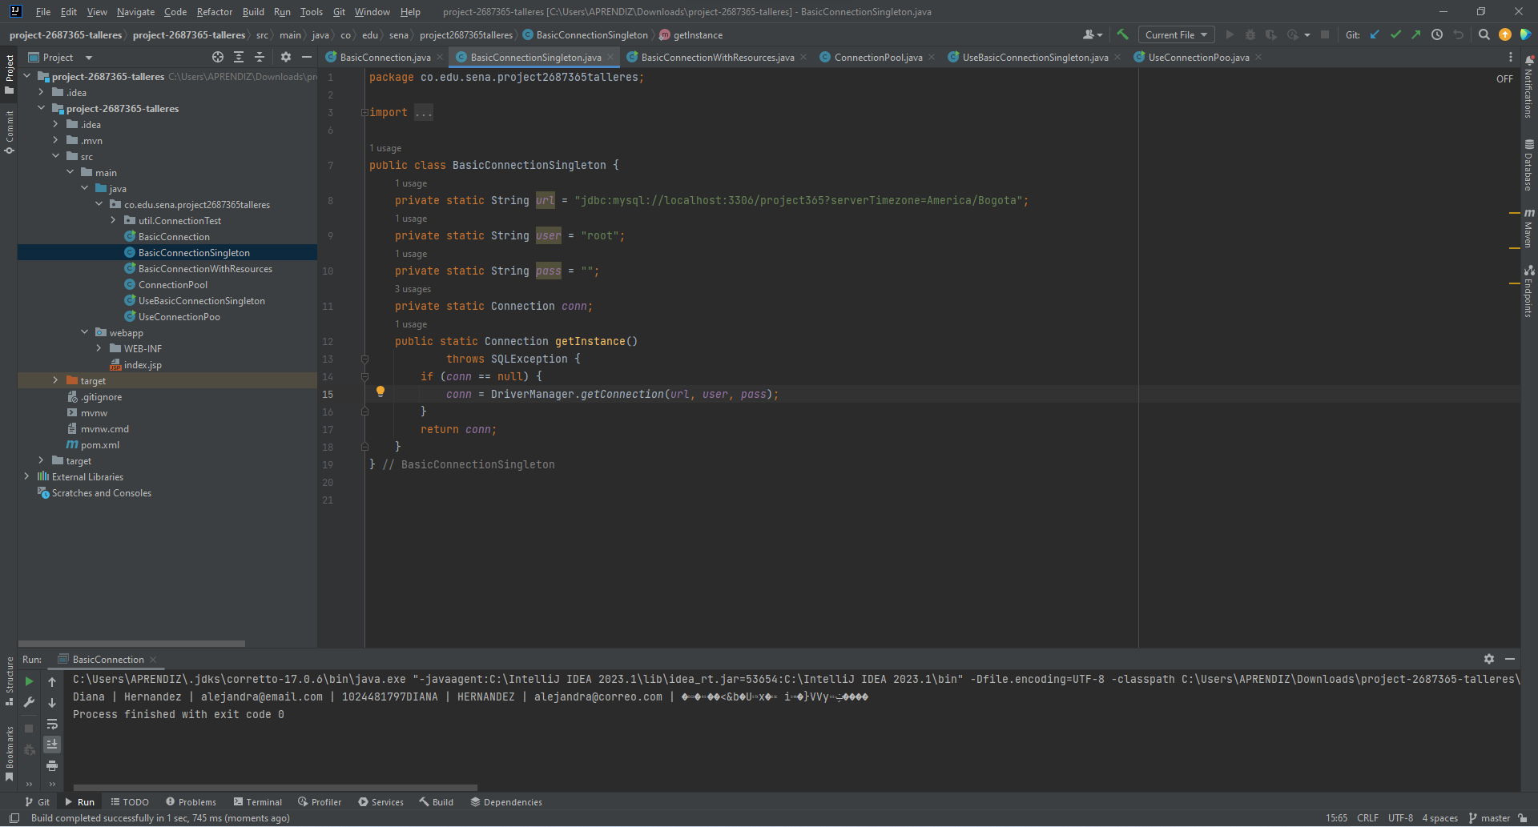

**CLASE: BasicConnectionWithResources:**

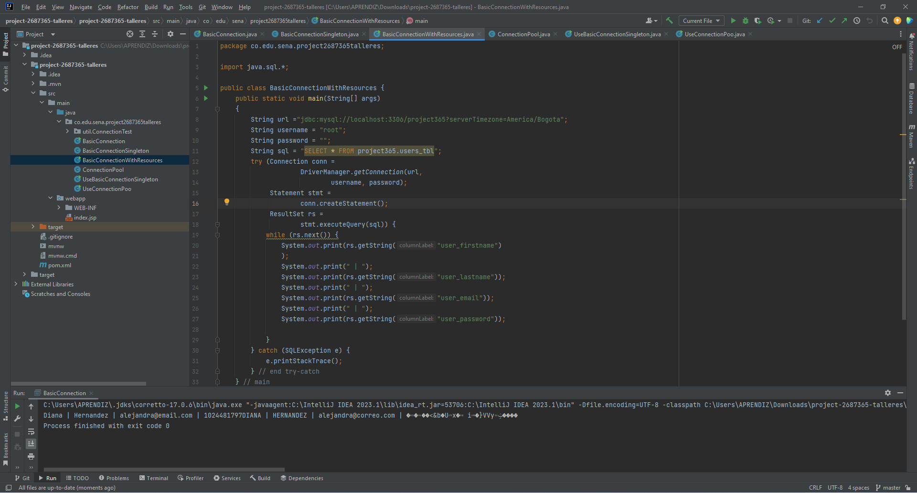

**CLASE: ConnectionPool:**

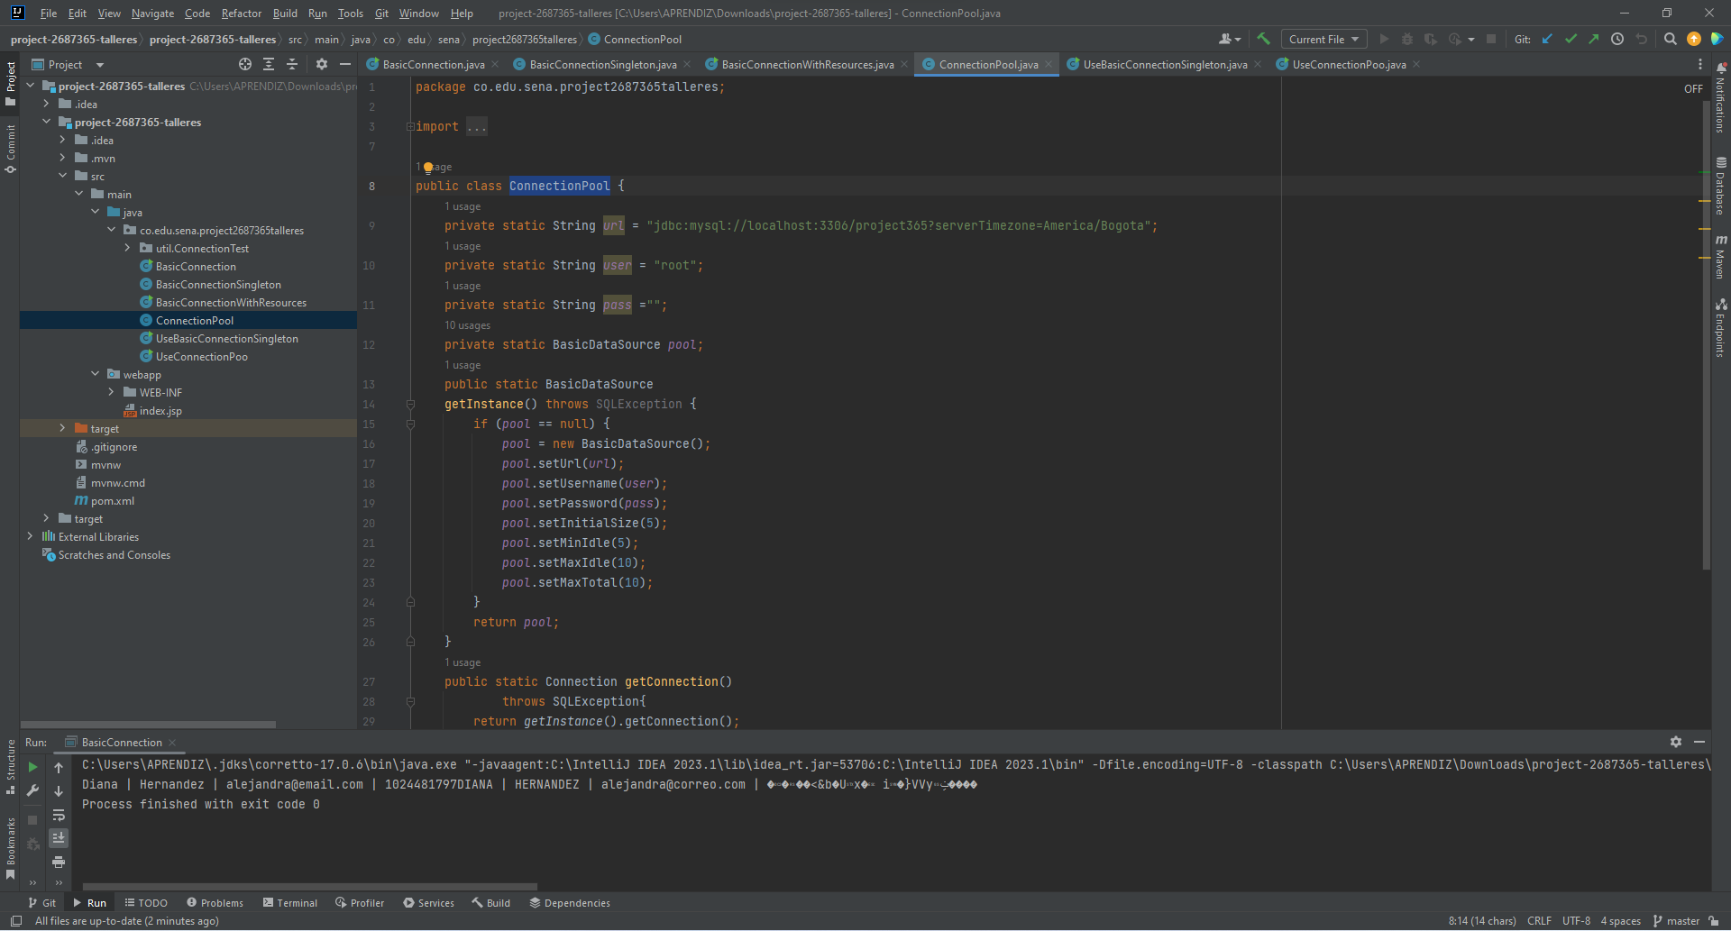

**CLASE: UseBasicConnectionSingleton:**

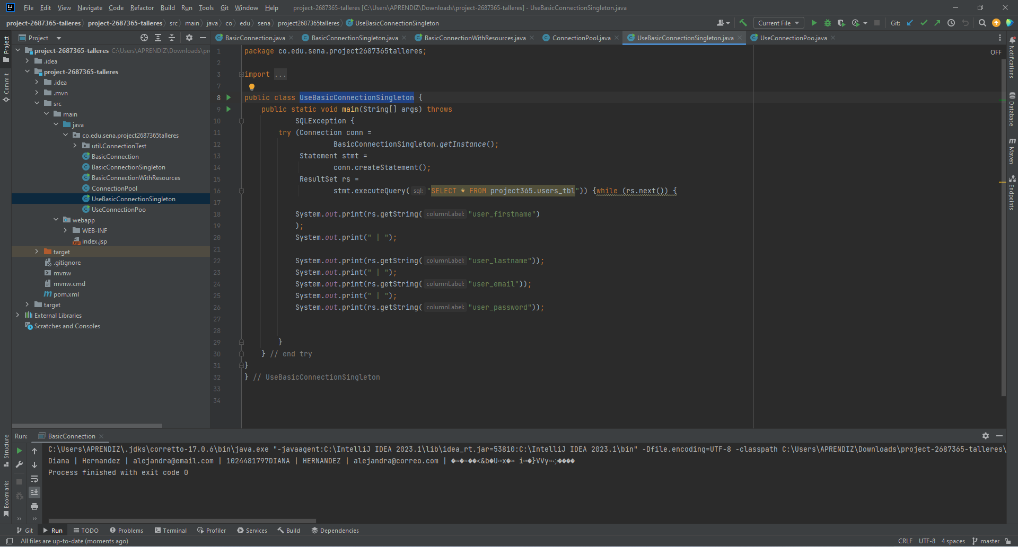

**CLASE: UseConnectionPoo:**

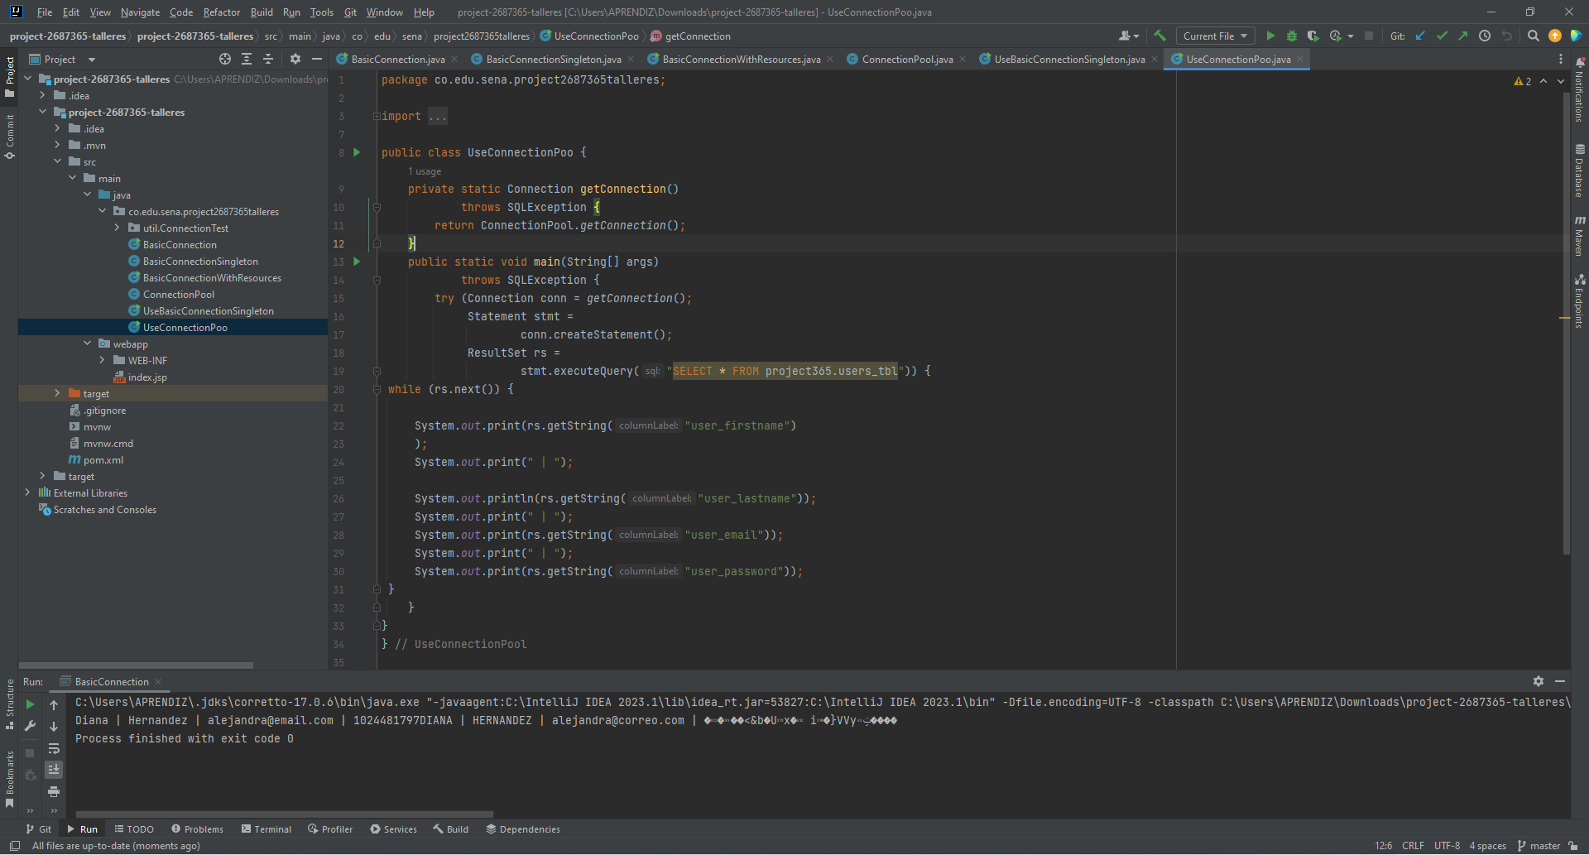

**DIANA ALEJANDRA FANDIÑO HERNÁNDEZ.**